How to plan cooperation with e-volunteers?
24 May 2016 Marzena Kacprowicz For organizers, Advices 0
The main strength of the e-volunteering projects are e-volunteers – people supporting the project through the use of the Internet, who do it voluntarily and without expecting to be paid for it. Their activity is unlimited because they can help an organization whose headquarter was located hundreds of kilometres away from the place they live. And although they might not have a chance to meet the project’s promoters in person, they’re very engaged and carefully do their tasks. Volunteers are the treasure and we should take care of them. Therefore, how to prepare for the cooperation with
e-volunteers?

Direct vs. Large-Scale Cooperation
The cooperation with e-volunteers can be organized in a few ways, depending on the needs and the nature of the project. For example, we can distinguish:
- Direct E-volunteering – all the projects where relations between organizers and the e-volunteers look like those known from the traditional volunteering: e-volunteers are usually chosen in the recruitment process, then the organizers sign with the e-volunteers a memorandum of understanding on e-volunteering service providing, allocate each of the volunteers with tasks and monitor their progress. For example, Kamień z Serca – a Polish non-profit online counselling service for young victims of sexual abuse. The e-volunteers working on the project are people trained by the organizer
- Large-scale E-volunteering – all the projects in which a large number of people takes part, and the tasks are performed on the crowdsourcing basis. Often, everyone can join this type of projects. There is no recruitment involved, and a memorandum of understanding on e-volunteering service providing is replaced with the regulations or policy of the website/app through which e-volunteering is being performed. For example, Wikipedia – everyone who has a will can join the team of editors of the world’s largest free encyclopaedia.

Direct E-volunteering
If you are going to create a closed team of the e-volunteers involved in your project, i.e. you are planning a recruitment which would enable you to choose the cooperators, you can use a cycle of cooperation with e-volunteers (cykl współpracy z e-wolontariuszami) when planning the cooperation. It helps you to identify step by step the needs and choose tasks for the e-volunteers. It also enables you carry out a recruitment of the volunteers, finding out how to maintain a high level of motivation among them, as well as how to monitor and evaluate the tasks. The part I of the E-volunteering Handbook contains a detailed description of the above cycle.

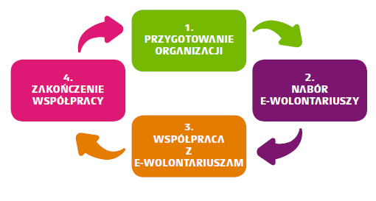

Large-scale E-volunteering
If you are planning to organize a project which could be joined by the Internet users, we recommend reading the article “Crowdsourcing” (part II of the E-volunteering Handbook). You can find there all the information about how the e-volunteers can contribute to this type of projects, how to find the e-volunteers and encourage them to cooperate with you, as well as how to monitor the results and use the wisdom of the crowd.
We encourage you to use an e-volunteering tool – the TuDu.org.pl platform. It is the first crowdsourcing platform based on volunteering competency, which is dedicated to the Polish third sector. Non-profit organizations (NGOs) can cooperate online with volunteers through the platform. NGOs post tasks for volunteers on TuDu, which are performed directly through the application. Within the first 6 months of its activity, TuDu.org.pl had 650 registered users who together created and solved 60 projects and 150 tasks respectively (The infographic summarising the 6 months is available here: http://blog.e-wolontariat.pl/2016/03/tudu-ma-juz-6-miesiecy-infografika/). The TuDu’s e-volunteers are ready to help with your project, too! ☺

The Main Thing: Be Prepared!
If you put enough effort into the planning stage, you will become convinced that the cooperation with e-volunteers is pleasant and effective. After all, together we can do more!

You can entry the “Discover E-volunteering” contest until 5 June 2016.

If you have any questions about the competition, feel free to telephone +48 22 825 70 22, or email konkurs@e-wolontariat.pl.

