As part of the project there was carried out a survey among the Ukrainian non-governmental organizations (198 organizations from all divisions of the country took part). Also, there was released three language versions, i.e. Polish, English and Ukrainian, of the E-volunteering Handbook. In the first week of its release the handbook was downloaded more than 800 times. It is free and available in the following formats: pdf, EPUB, MOBI. It can be downloaded from websites such as e-wolontariat.pl and e-volunteering.eu.
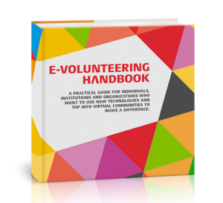
The project was funded under the Polish-American Freedom Foundation's “Region in Transition” (RITA) Program, which was implemented by the Education for Democracy Foundation.

Organizer
Good Network Foundation

Partners
GURT Resource Centre
The NGO Institute of Creative Technologies and Mass Media
Volunteering Сentre "Dobra Volya" and Kherson Charitable Foundation "Union".

It is often difficult for NGOs to establish cooperation with companies as the NGOs do not know what could it look like, how to start, or how they could benefit from it. Companies usually associate cooperation with a pure fundraising, e.g. with the acquisition of a grant from the company for the implementation of a social project. But that is not the only way! Equally important (and perhaps even more important due to building up long-term relationships) is the non-financial cooperation that can be done in form of corporate volunteering.

The workbook
Good Network Foundation together with other organizations and companies associated in the network called the Employee Volunteering European Network, prepared the Employee Volunteering Workbook: a brief workbook for NGOs ready to start a project involving employees of any chosen company. The workbook has been divided into sections, each of which is dedicated to a different phase of cooperation. It also contains a lot of subsidiary questions, tips and exercises you should do with the company. As a result, both sides will be sure that they understand the objectives and activities provided for in their project and perceive them in the same way.
In addition, the workbook shows several different models of cooperation that can be implemented as part of corporate volunteering. One of them is the e-volunteering 
Feel free to read it!
Polish version of the workbook: EVEN Workbook_PL
English version of the workbook: CEV_EVEN_EV_Workbook_GNF

The workbook was translated from English into Polish by our two e-volunteers: Lucyna Błachnia and Radosław Dudek. Thank you!

