The mission of the Good Network Foundation is to disseminate knowledge related to social use of new technologies and the strengthening civil society development in Poland.
In order to do it, we are running projects supporting the development of local and national communities, as well as international action partnerships facilitating the exchange of experiences between countries of Europe and of the world.
We are willing to collaborate with organizations, institutions and companies. This can be done on various fields.

1. How the Good Network Foundation collaborates with other organizations and institutions.
If you want:
- your organization or institution to make better use of new technologies in their work
- your local community to be more dynamic
- your charges to learn how to look for scholarships
- learn how to organize volunteering and e-volunteering
- learn how to create a good scholarship program
- promote your scholarship program
- carry out a joint partnership project with the Good Network Foundation,
please contact us and see our training offer or present your own project proposal. We are happy to share our experience and learn something new from you!

So far, among other things, we have carried out the following:
- local training in Act Locally Centres (Osrodki Działaj Lokalnie), Tech Clubs (Tech Kluby), Orange Shops (Pracownie Orange)
- training for representatives of organizations and institutions as part of the Sector 3.0 conference, Presidents-Volunteers coalition conference, Volunteer Festival and others
- workshops during symposiums European Volunteer Centre - CEV
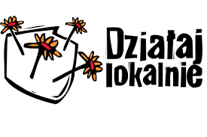

2. Your create a project - we carry it out: or, cooperation between the Good Network Foundation and companies.
The Good Network Foundation Team consists of people having experience in cooperation with the business sector. We are open to your ideas for social projects and will gladly support their development, as well as take care of their completion.
We can help you to:
- create the concept of the social involvement of your company
- organize a grant program for your employees
- create a scholarship program for families of your employees, people around you
or to create any other program
- involve employees in on-line and off-line social activities
Our projects:
- HOPE Volunteers - corporate volunteering at Nutricia
- The Natalia Partyka Scholarship Fund (Fundusz Stypendialny Natalii Partyki) and the www.damnasport.pl crowdfunding platform in collaboration with Biedronka (chain of retail stores in Poland)
- mPotęga in collaboration with mBank
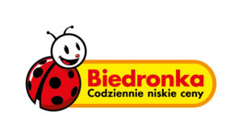

3. Technological cooperation
The Good Network Foundation organizes activities on a national and European level. We are open to barter cooperation, which can technologically support our initiatives.

